

Espresso Charge

Work Instruction & Firmware Flashing Procedure for espressoCharge  
espressoCharge工作说明和固件刷新程序

[WI-00001](https://app.bom.com/items/detail-spec?item_id=1345001210&version_id=12913539778&redirect_seqno=19493729237)

# Revision Table 修订表

| **Date 日期** | **Revision 修订** | **Author 作者** | **Comment 评论** |
| --- | --- | --- | --- |
| 28 August 2023 | v1.0 | Ahmed Ali | Original Issue |

# Approval 审批

| Fabian Maritato |  |
| --- | --- |
| Chris Hook | Reviewed - no additional comments; 29 Aug 2023 |

# Table of Contents 目录

**Revision Table 1**

**Approval 1**

**Table of Contents 2**

**Version Tracking 3**

**Purpose and Scope 4**

**Equipment and Materials 4**

**Preparations 5**

**Firmware Flashing Procedure 10**

**Revision History 17**

# Version Tracking 版本追踪

# 

| **Item 项** | **Version 版本** | **Notes 笔记** |
| --- | --- | --- |
| espressoCharge PCBa | RevA |  |
| espressoCharge Firmware 固件 | v1.0.0 |  |
| ST-LINK Hardware 硬件 | V2 |  |
| ST-LINK firmware upgrader software 固件升级软件 | v3.13.4 |  |
| STM32Cube Programmer 编程器 | v2.14.0 |  |
| CP210x VCP Driver 驱动程序 | v11.3.0 |  |
| Python | v3.9.7 |  |
| Host Computer 主机 | Windows 11 |  |

# 

# 

# Purpose and Scope 目的和范围

The purpose of this work instruction is to provide step-by-step guidelines for the accurate and efficient flashing of firmware onto espressoCharge PCBa. By following these instructions, users can ensure the proper functioning and reliability of the PCB through the correct installation of firmware. This process is essential for maintaining the intended performance and features of the PCB, contributing to overall product quality.  
本工作说明的目的是为将固件准确、高效地刷新到 espressoCharge PCBa 上提供分步指南。 通过遵循这些说明，用户可以通过正确安装固件来确保 PCB 的正常运行和可靠性。 此过程对于维持 PCB 的预期性能和功能至关重要，有助于提高整体产品质量。

This document covers the procedures and precautions required for successful firmware installation on the specified PCB model. The instruction is intended for use by personnel responsible for performing firmware flashing tasks. It does not encompass modifications to hardware components, circuit design, or any other processes beyond the firmware flashing procedure.

本文档介绍了在指定 PCB 型号上成功安装固件所需的过程和注意事项。 该说明旨在供负责执行固件刷新任务的人员使用。 它不包括对硬件组件、电路设计或固件刷新过程之外的任何其他过程的修改。

# Equipment and Materials 设备与材料

* Computer with compatible operating system (Windows 10 or higher).  
  具有兼容操作系统的计算机（Windows 10 或更高版本）。
* USB-C to USB-C cable.  
  USB-C 电缆。
* espressoCharge PCBa with Battery Pack “5S2P”.  
  带电池组“5S2P”的 espressoCharge PCBa

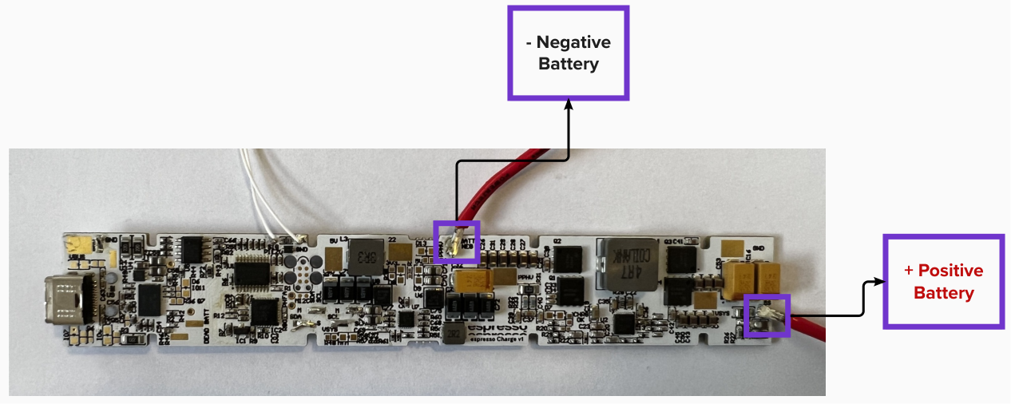

espressoCharge PCBa with Battery Terminals 带电池端子的 PCBa

* Firmware files compatible with the PCB revision.  
  固件文件与 PCB 版本兼容。
* ST-LINK/V2 with Tag connect In-Circuit Cable “TC2030-MCP”.  
  ST-LINK/V2 带标签连接在线电缆“TC2030-MCP”。

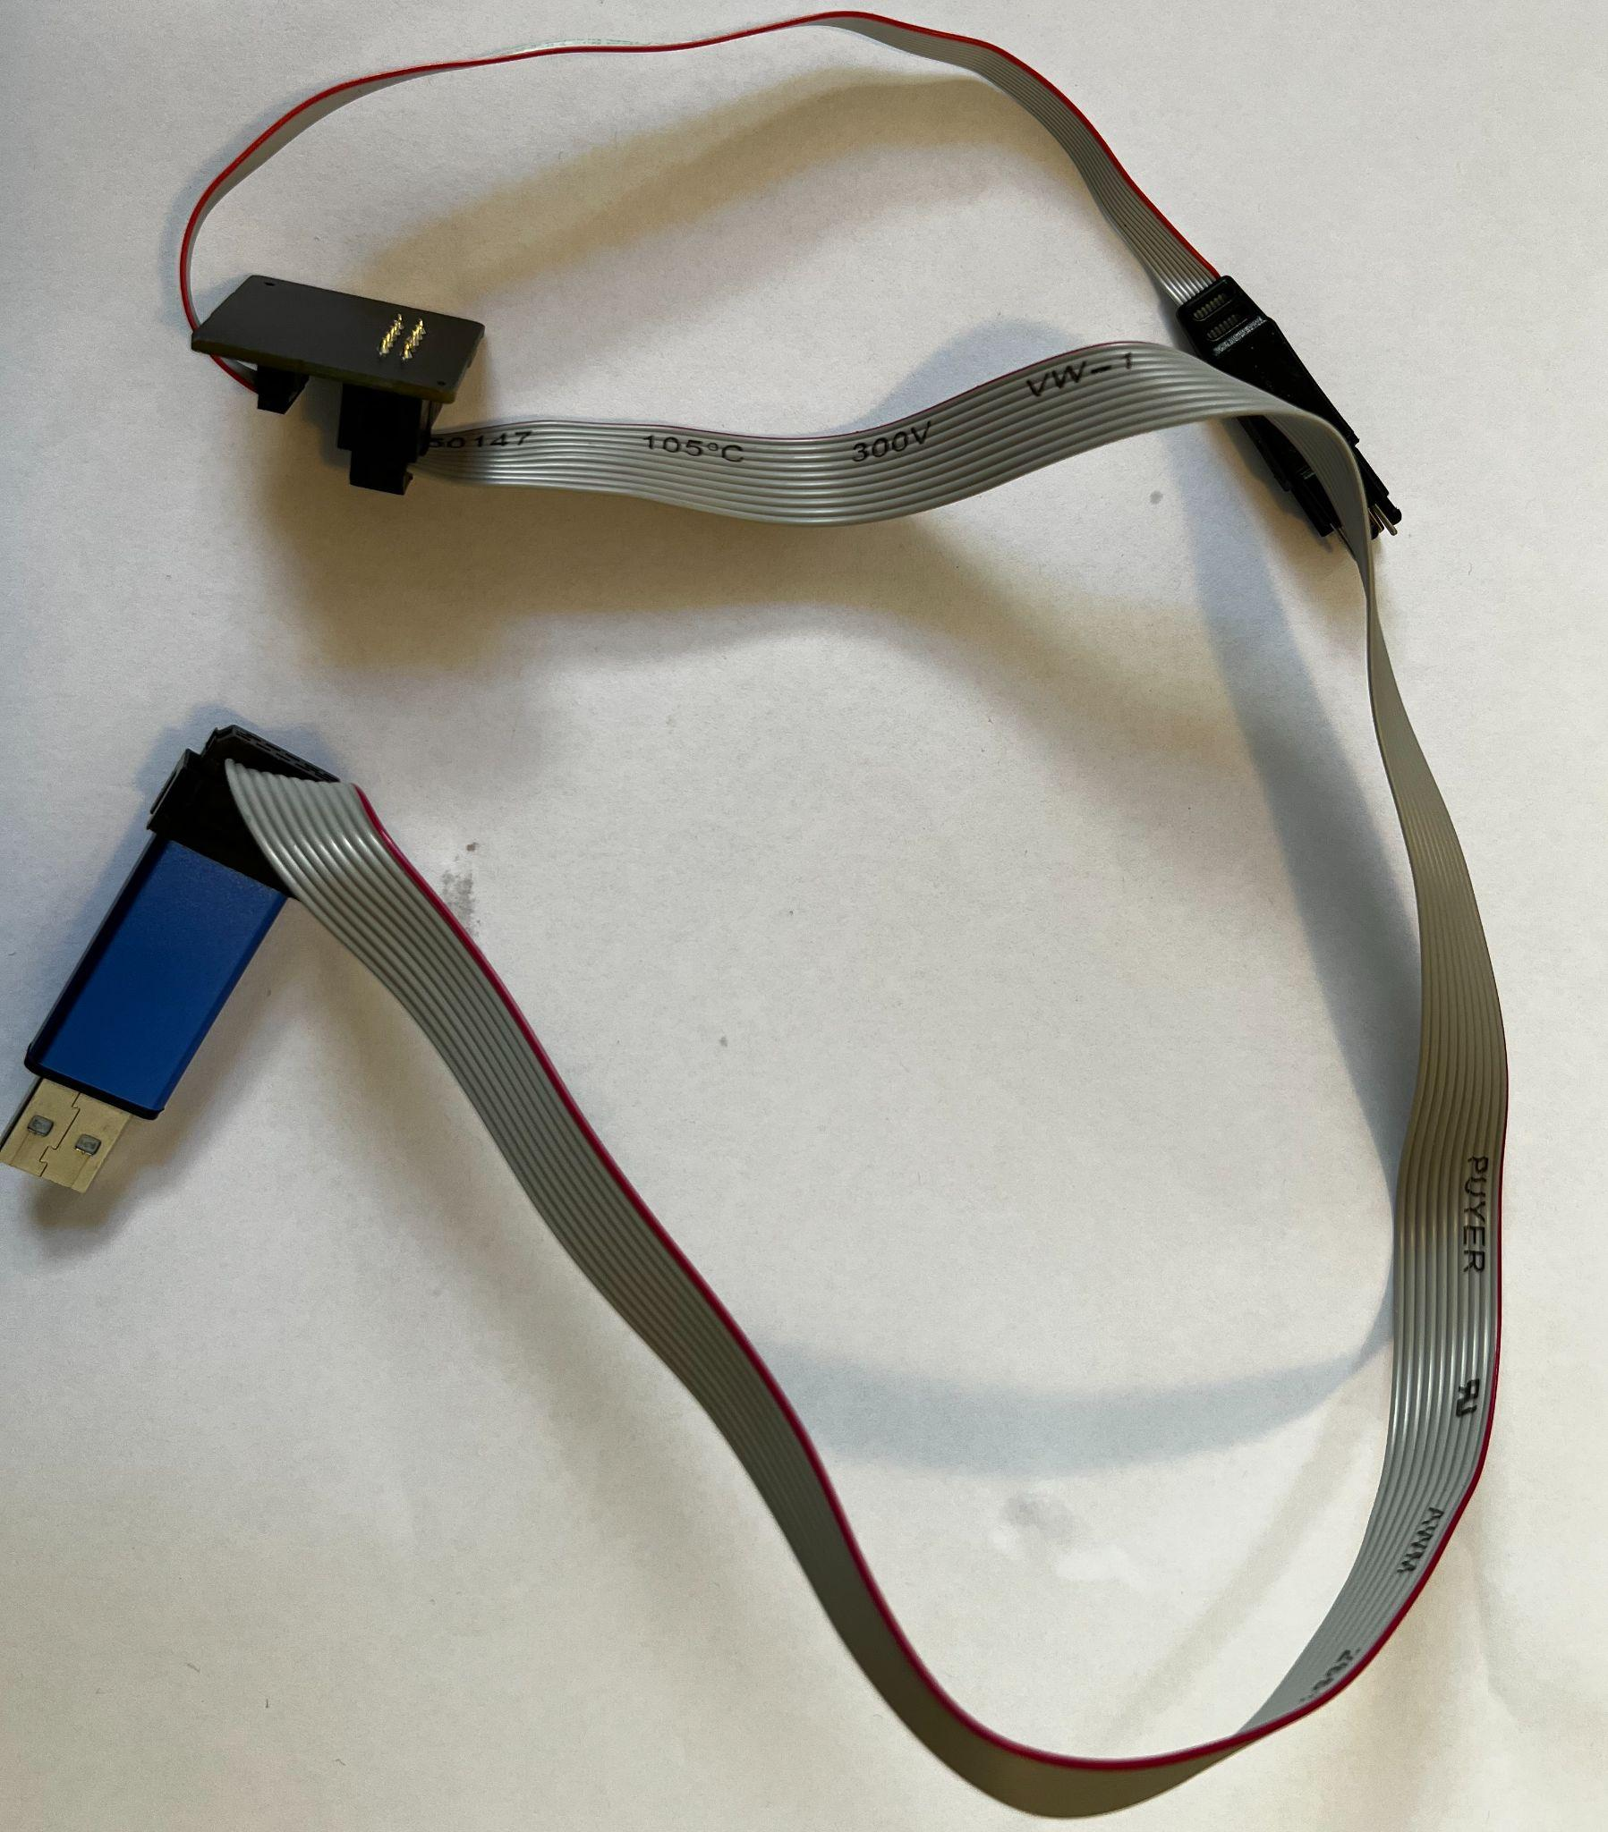

ST-LINK/V2 with Tag Connect

# Preparations准备

* Install necessary software and drivers on the computer “All necessary software and drivers should be provided and found in the “[WIP](https://drive.google.com/drive/folders/1Xs4q9ibhH7Nyonolu1csyW1GgFaRMhyQ?usp=drive_link)” folder.  
  在计算机上安装必要的软件和驱动程序 “应提供所有必要的软件和驱动程序，并可在“WIP”文件夹中找到它们。
* Ensure Internet connection.  
  确保互联网连接。
* Install “STM32CubeProgrammer” software.安装“STM32CubeProgrammer”软件。  
  Found in 位于**\WIP\Software\STM32CubeProgrammerSW\SetupSTM32CubeProgrammer_win64.exe**
* Install ST-LINK firmware upgrader software, then upgrade its firmware.  
  安装ST-LINK固件升级软件，然后升级其固件。  
  Found in位于  
  **\WIP\Software\STLINK-FW-Upgrader\stsw-link007\Windows\ST-LinkUpgrade.exe**

**How To: 如何:** 1)Open ST-LinkUpgrade.exe, then a window will pop.  
 打开ST-LinkUpgrade.exe，然后会弹出一个窗口。

2) Then Connect the USB end of ST-LINK to the PC and make sure the LED on it  
 turns on. 然后将ST-LINK的USB端连接到PC上，并确保其上的LED亮起  
 3) Click on the “Device Connect” Button. 单击“Device Connect设备连接”按钮。

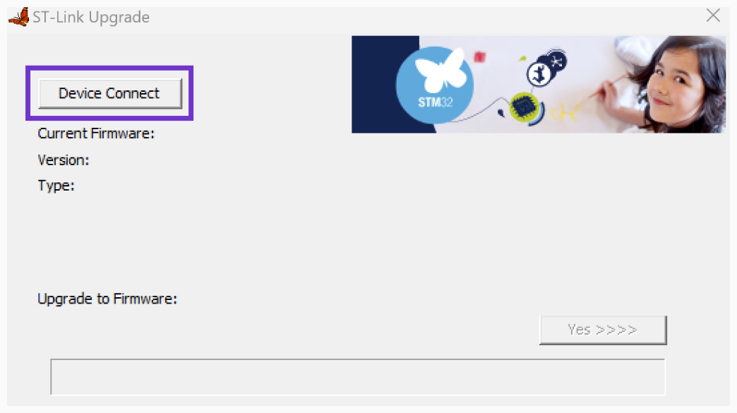

4) If the device is successfully connected the current firmware info will be logged  
 in the window. 如果设备连接成功，当前固件信息将记录在窗口中。  
  
 5) Click on “Yes” Button and wait for firmware to be downloaded & installed.  
 单击“是”按钮并等待固件下载并安装。  
  
  
 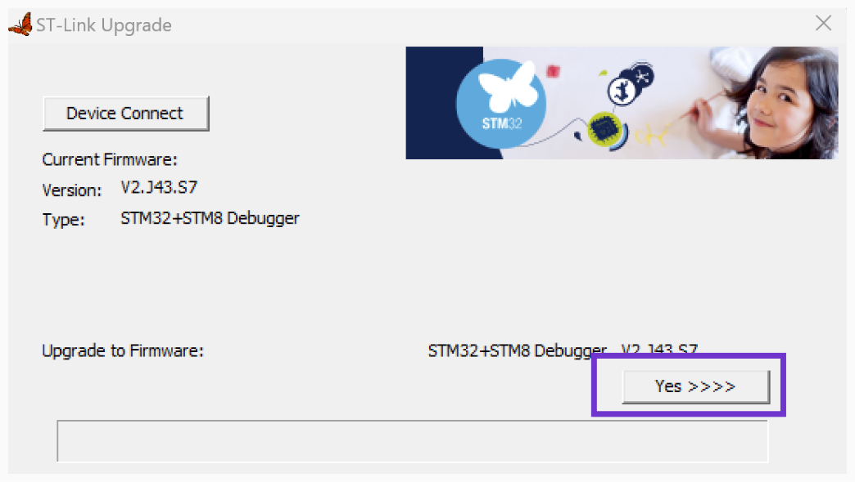

6) If the firmware upgrade process was successful a pop up message will appear, then you can close the program.  
如果固件升级过程成功，将出现一条弹出消息，然后您可以关闭该程序。

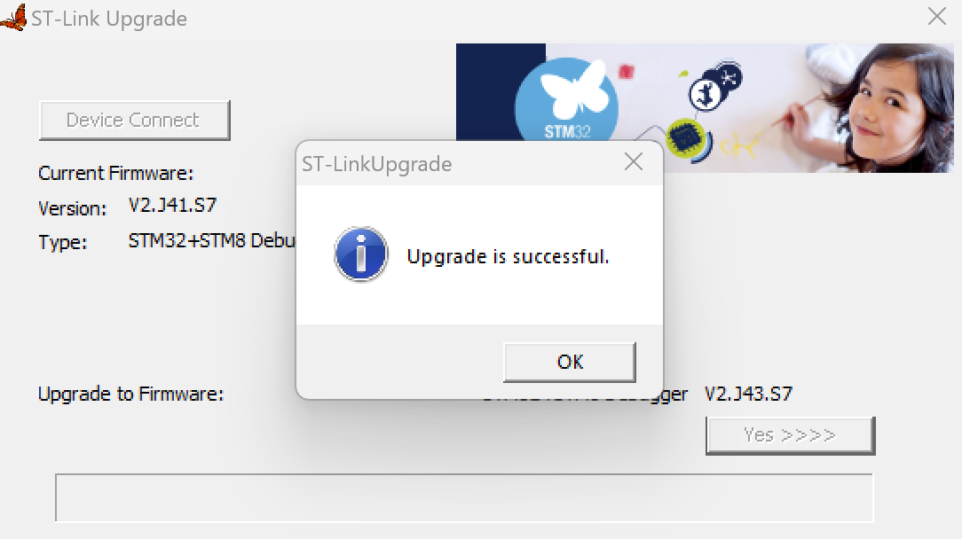

* Install the driver for CP210x. 安装 CP210x 的驱动程序。  
  Found in 位于  
  **“\WIP\Drivers\CP210x_Universal_Windows_Driver\”**

**How To: 如何:** 1)Plug-in the USB-C cable into the espressoCharge port and to the PC.  
 将 USB-C 电缆插入 espressoCharge 端口和 PC。

2) Open Device Manager program.  
 打开设备管理器程序。  
 3) Look for the “Ports” section and expand it. If you are able to see the “CP210x”  
 driver with the associated COM number like shown in the image below for  
 Example “COM12” in this case, note: the number might not be the same. This   
 shows that the driver is already installed and you don't need to continue  
 with the following steps.

查找“端口”部分并将其展开。 如果您能够看到“CP210x”驱动程序以及相关的 COM 编号（如下图所示，在本例中为“COM12”示例），请注意：该编号可能不同。 这说明驱动已经安装好了，不需要继续下面的步骤。

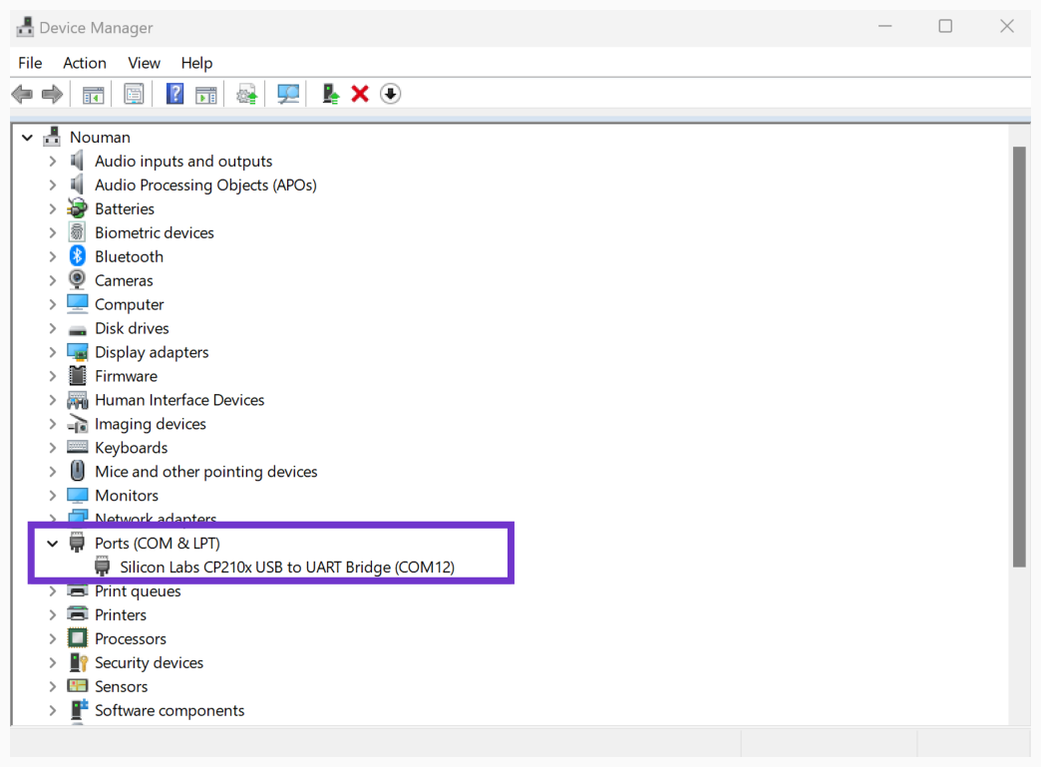

4)If you don’t see the COM number, right click on the text with “CP210x” and  
 select “Update Driver” from the drop-down menu.  
如果您没有看到 COM 编号，请右键单击带有“CP210x”的文本，然后从下拉菜单中选择“更新驱动程序”。

5) Another window will pop up, make sure you select “Browse my computer for  
 Drivers.  
 将弹出另一个窗口，确保选择“浏览我的计算机以获取驱动程序”。

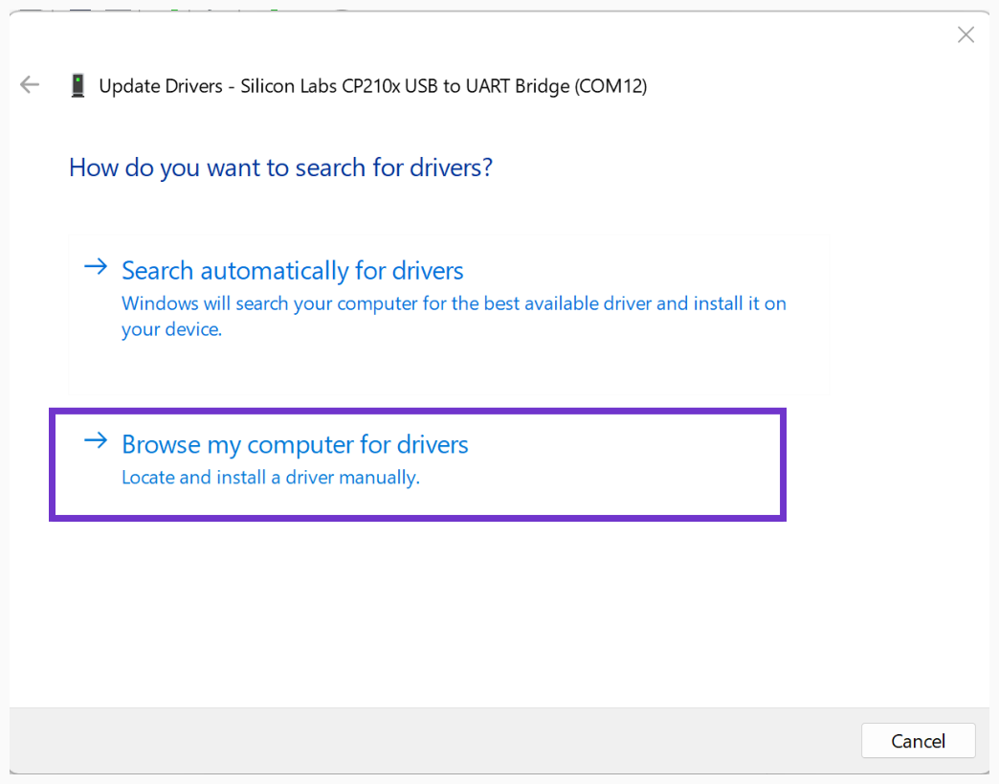

6) In the next window, click on “Browse”. 在下一个窗口中，单击“浏览”。

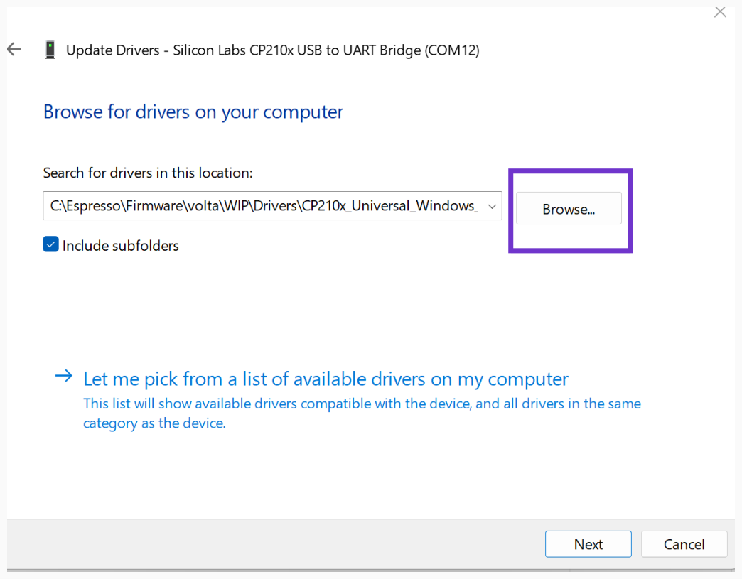

7) Navigate and select the “CP210x_Universal_Windows_Driver” folder.  
 导航并选择“CP210x_Universal_Windows_Driver”文件夹。

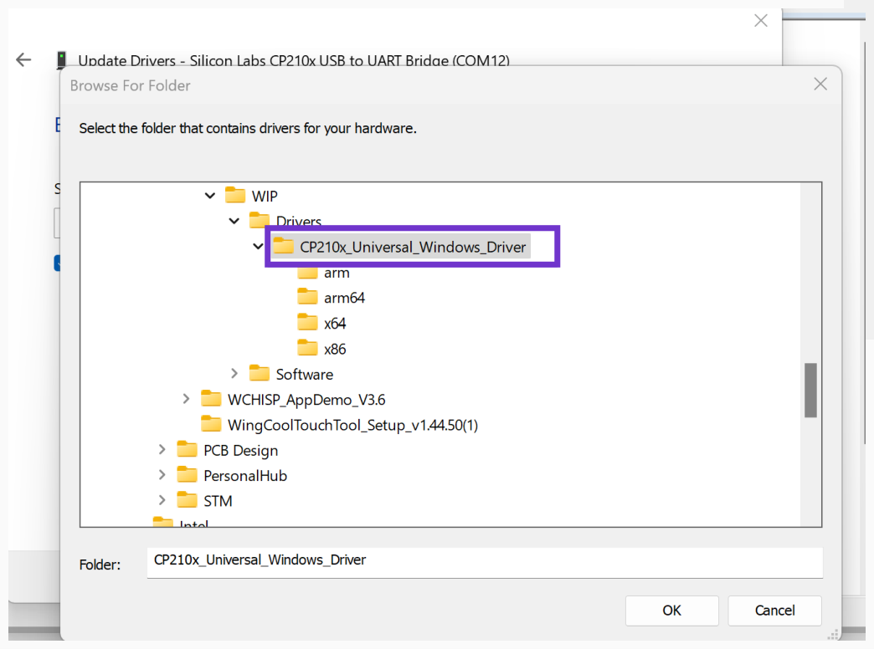

8) Click on “OK” and then click “Next” and follow the prompt to install the driver.  
 点击“确定”，然后点击“下一步”，按照提示安装驱动程序。

9) On successful installation, the driver and driver’s COMx number will appear in  
 like in step (3).  
 安装成功后，驱动程序和驱动程序的 COMx 编号将出现，如步骤 (3) 所示。

* Install Python. 安装 Python  
  Found in 位于  
  **“\WIP\Software\Python\python-3.9.7-amd64”**

**How To: 如何:** 1)Open 打开 **python-3.9.7-amd64**.

2) Ensure that you check the Add to Path box. Then, click on “Install Now”.  
 确保选中“添加到路径”框。 然后，单击“Install Now立即安装”。

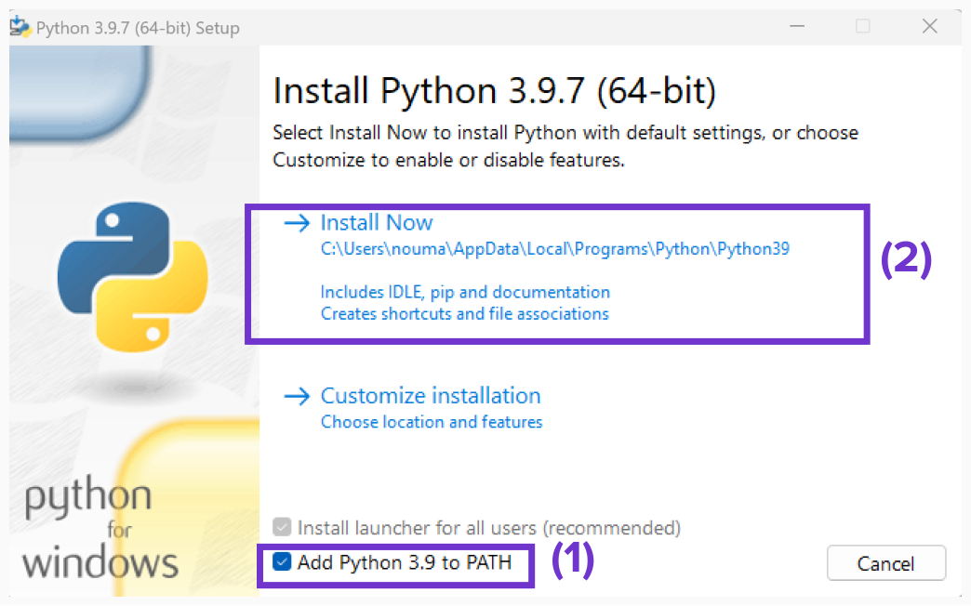

3) Follow the prompt for installation. 按照提示进行安装。

4) Open the “CMD” terminal and navigate to this folder:  
 打开“CMD”终端并导航到此文件夹：  
 **“\WIP\Software\Python\”**

5) In the terminal, type in “pip install -r requirements.txt” then hit enter.  
 在终端中，输入“pip install -r requests.txt”，然后按 Enter 键。

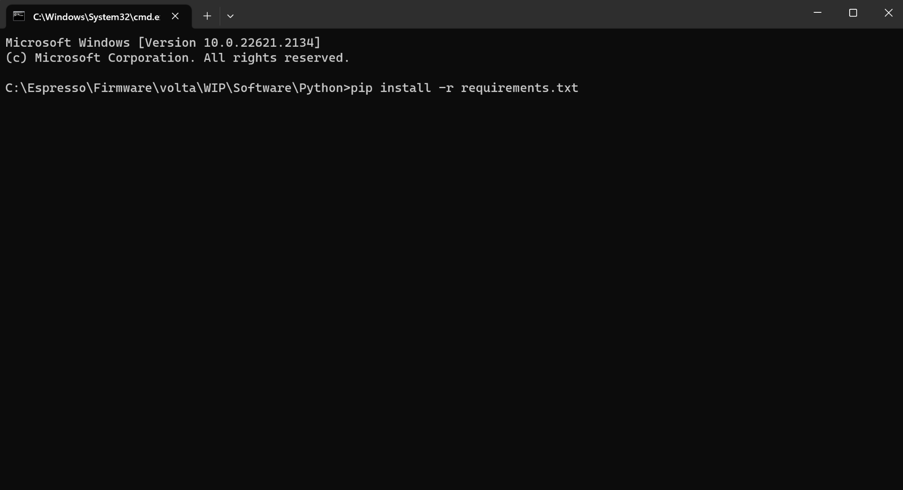

# Firmware Flashing Procedure 固件刷新程序

1. After Installing all drivers and software, Locate the Tag Connect header on the PCBa.  
   安装所有驱动程序和软件后，找到 PCBa 上的标签连接接头。

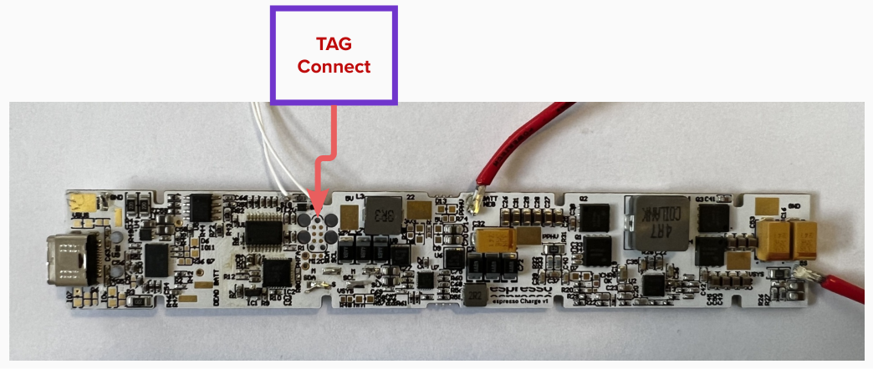

1. Plug in the Tag Connect to the PCBa first. Ensure that it is securely attached as demonstrated in the images below “Confirm that the connector orientation is correct”.  
   首先将 Tag Connect 插入 PCBa。 确保其连接牢固，如下图所示“确认连接器方向正确”。

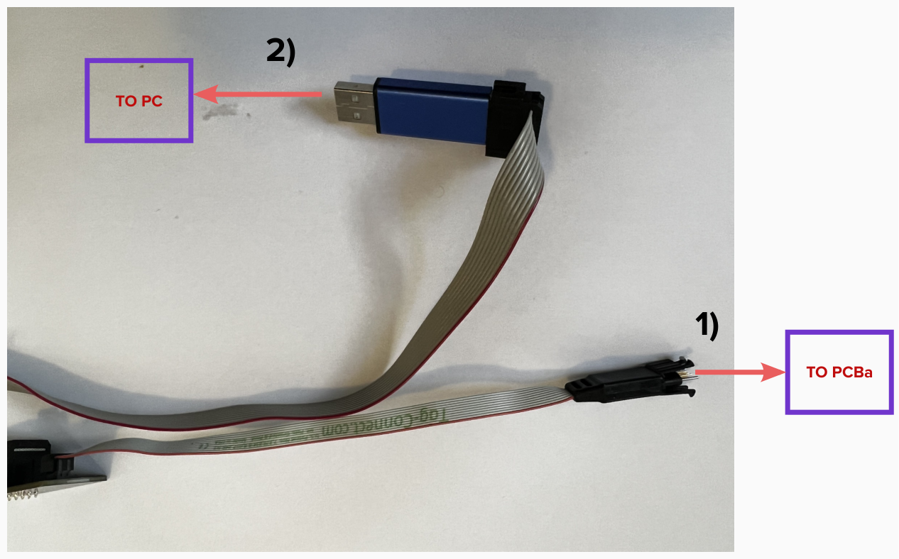

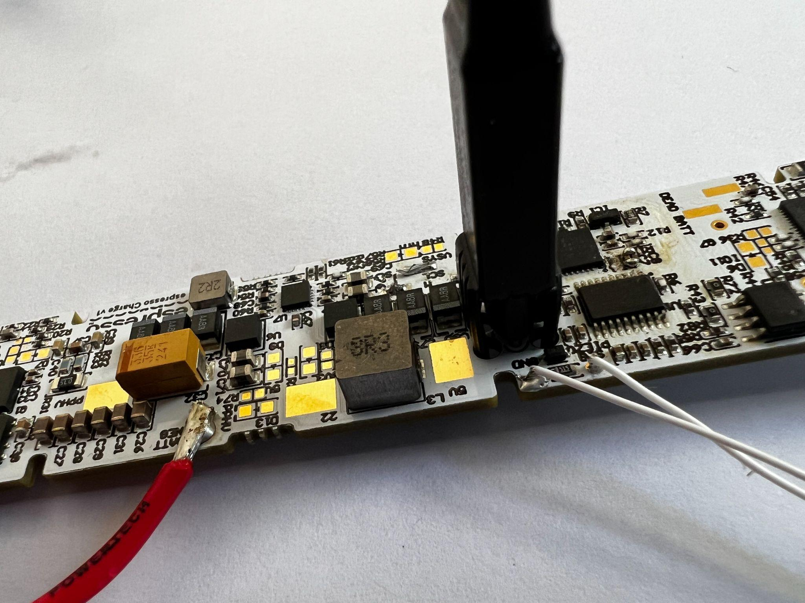

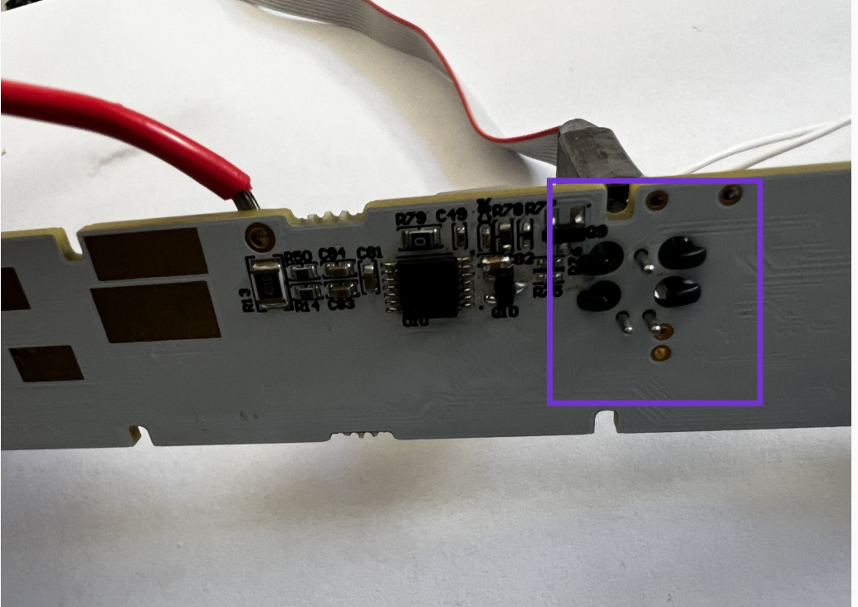

1. After attaching the Tag Connect to the PCBa, connect the USB end to the PC and ensure that the LED on the ST-LINK is on. Note: “connect to PC after attaching to PCBa”.

将Tag Connect连接到PCBa后，将USB端连接到PC并确保ST-LINK上的LED亮起。 注：“连接到 PCBa 后连接到 PC”。

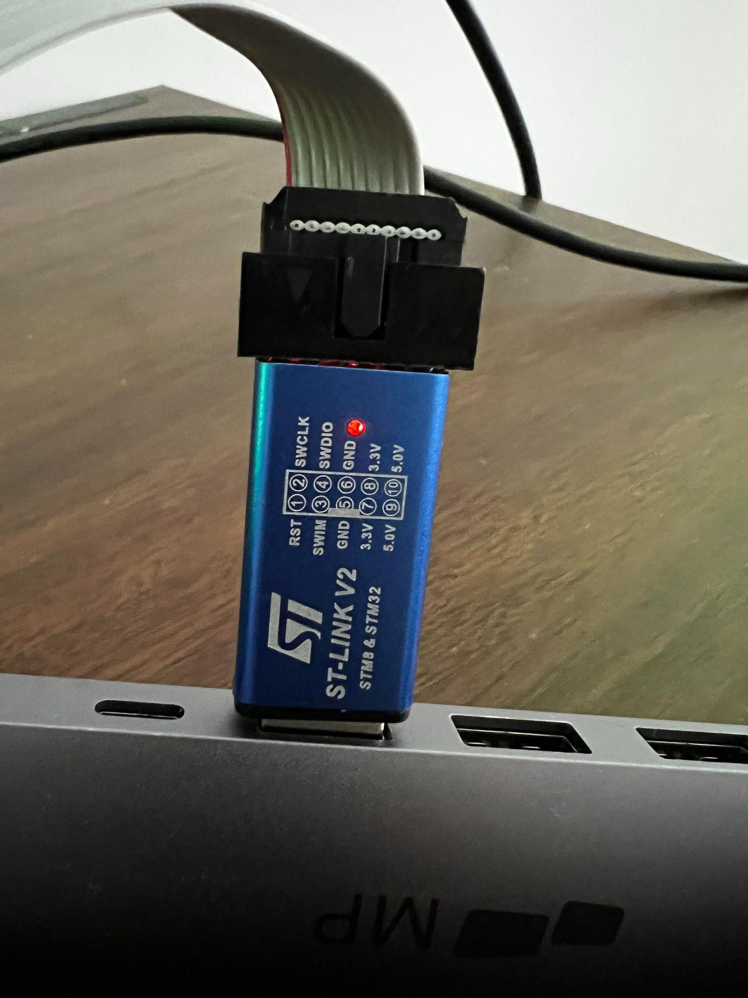

1. Open STM32CubeProgrammer and follow the steps in the image, ensure “Shared” is enabled, then click on the refresh button then make sure that the serial number is selected, then click on connect.  
   打开STM32CubeProgrammer并按照图中的步骤操作，(1)确保启用(1)“Shared共享”，然后单击(2)refresh刷新按钮，确保选择(3)serial number序列号，然后单击(4)connect连接。

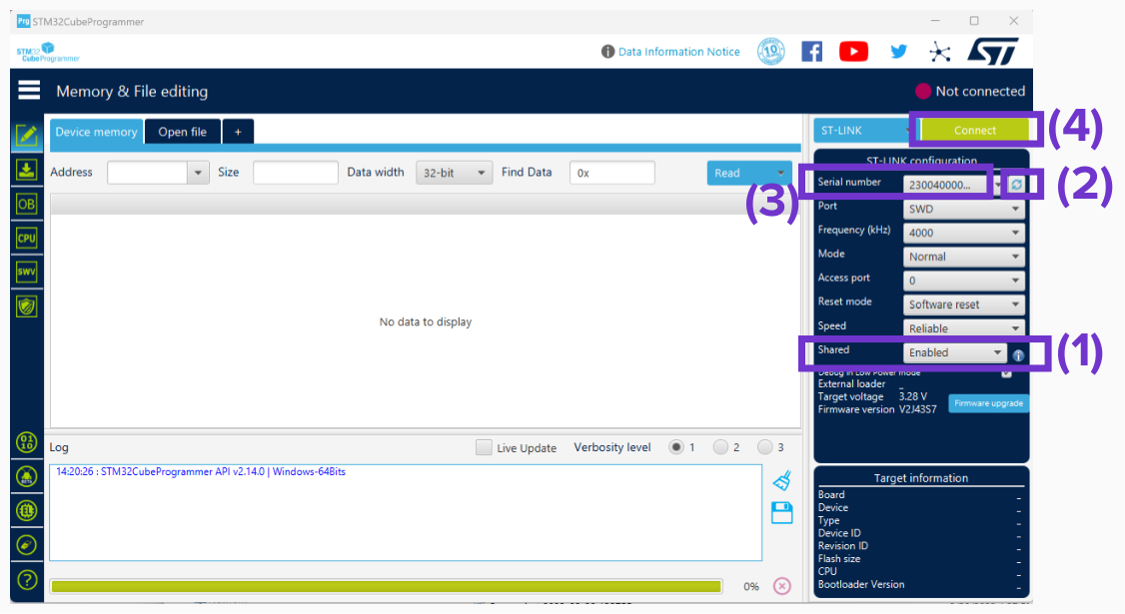

1. After connecting, ensure “Data read is successful” in the log messages and device info is shown in the bottom right corner of the program. Then, click on “Open file” and navigate to the correct version of the firmware file located in  
   连接后，确保日志消息中显示“数据读取成功”，并且程序右下角显示设备信息。 然后，单击“打开文件”并导航到位于以下位置的固件文件的正确版本  
   **“\WIP\espressoCharge-Firmware\main\espressCharge_v1_0_0.elf”**

Note:In this example we used 注意：在这个例子中我们使用 “espressCharge_v1_0_0.elf”

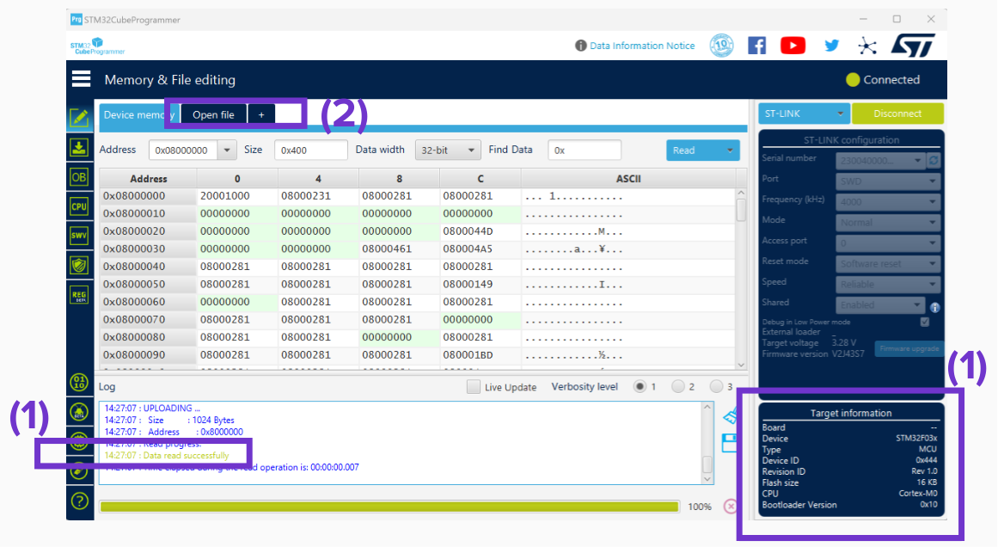

1. Click on “Download” button and make sure the logs show the “File download complete”  
   单击“Download下载”按钮并确保日志显示“File download complete文件下载完成”

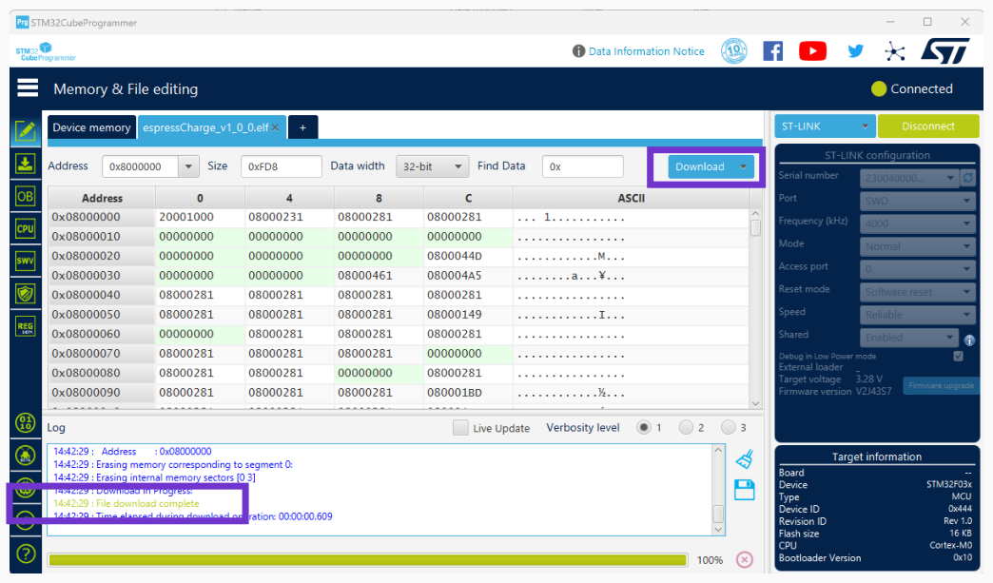

1. In this step, we verify the downloaded firmware for errors, click on the arrow on the “Download” button and select “Verify” from the drop-down menu. Then, ensure that the logs show “Verification successfully done, no data mismatch found”.  
   在此步骤中，我们验证下载的固件是否有错误，单击“Download下载”按钮上的箭头，然后从下拉菜单中选择“Verify验证”。 然后，确保日志显示“Verification successfully done, no data mismatch found验证成功完成，未发现数据不匹配”。

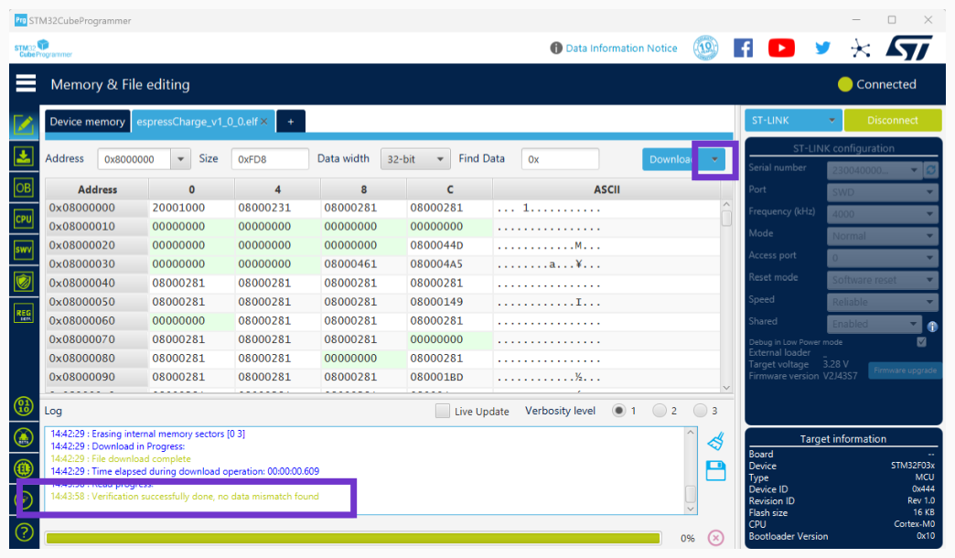

1. Main’s firmware has been flashed successfully.   
   Main的固件已经刷成功了。
2. Unplug the USB end of the Tag Connect from the PC.   
   从 PC 上拔下 Tag Connect 的 USB 端。
3. Plug-in the USB-C cable into the espressoCharge Port and to the PC.  
   将 USB-C 电缆插入 espressoCharge 端口和 PC。
4. Open ‘CMD’ on windows and navigate to this folder:  
   在 Windows 上打开“CMD”并导航到此文件夹：  
   **“\WIP\espressoCharge-Firmware\Peripheral-Firmware\”**
5. In the CMD terminal type in “python flash_peripherals.py” then hit enter, the log messages will show the firmware upgrade process of the peripherals. If the logs show a “Successful” message then the device is flashed with updated firmware.  
   在CMD终端中输入“python flash_peripherals.py”然后按回车键，日志消息将显示外设的固件升级过程。 如果日志显示“Successful成功”消息，则设备将使用更新的固件进行刷新。

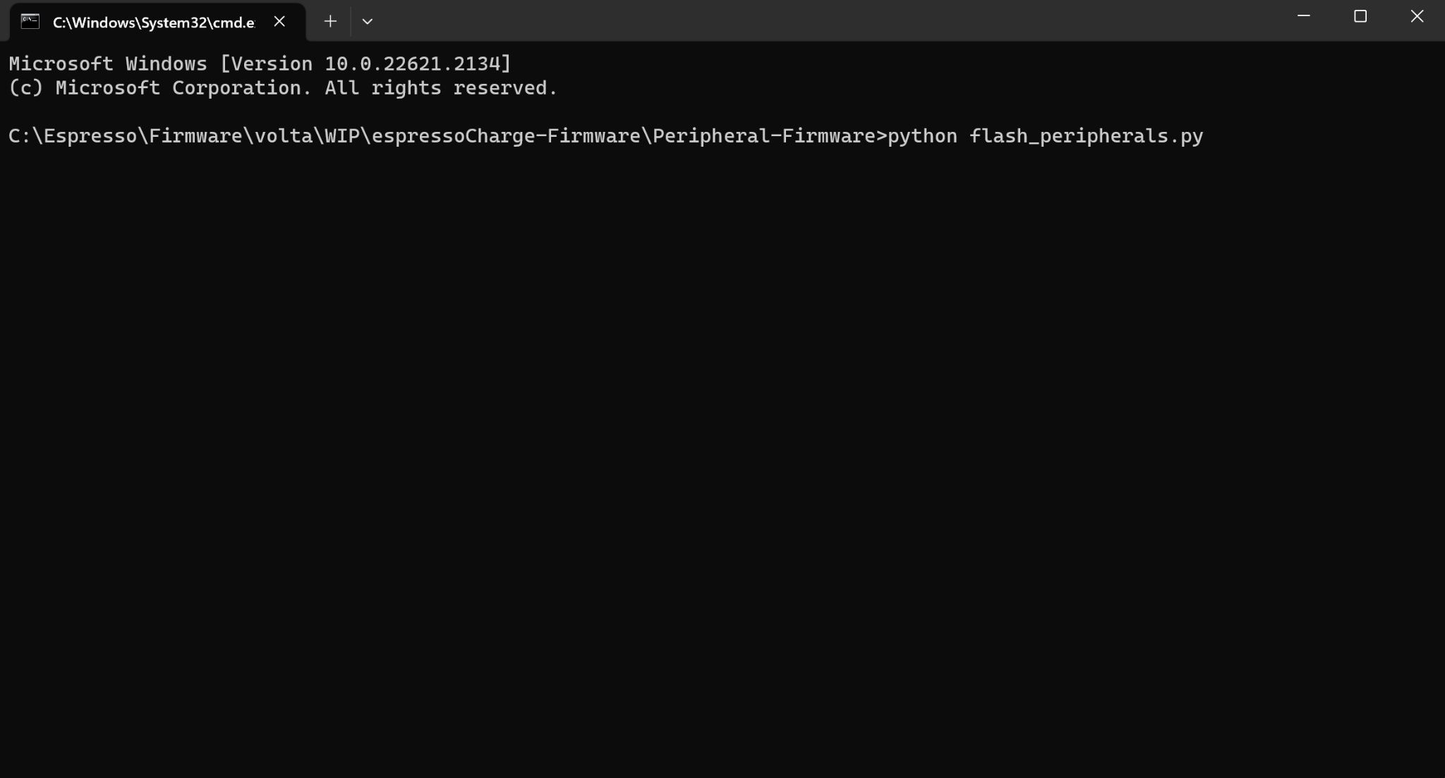

# Revision History 修订记录

| **Revision** | **Description of Change** | **Effective Date** |
| --- | --- | --- |
|  |  |  |
|  |  |  |
|  |  |  |
|  |  |  |